© Thomas Seilnacht

# Text

# Text

# Text

# Text

# Text

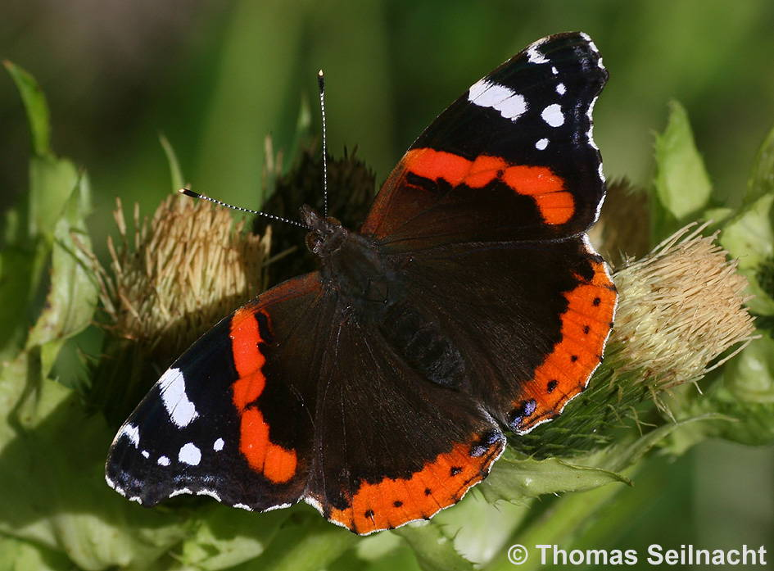

# Admiral

© Thomas Seilnacht

# Text

# Text

# Text

# Text

# Text

# Text

© Thomas Seilnacht

# Text

# Text

# Text

# Text

# Text

# Text

© Thomas Seilnacht

# Text

# Text

# Text

# Text

# Text

# Text

© Thomas Seilnacht

# Text

# Text

# Text

# Text

# Text

# Text