© Thomas Seilnacht

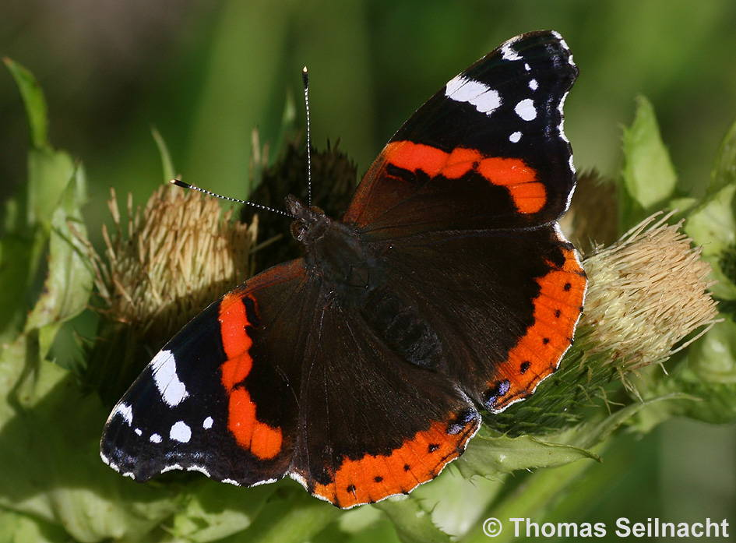

# Text

# Text

# Text

# Text

# Admiral

# Admiral (Beispielkarte)

# Text

# Text

# Text

# Text

# Text

# Admiral

# Text

# Text

# Text

# Text

# Text

# Text

# Admiral

# Text

# Text

# Text

# Text

# Text

# Text

# Admiral

# Text

# Text

# Text

# Text

# Text

# Text

# Admiral

# Text

# Text