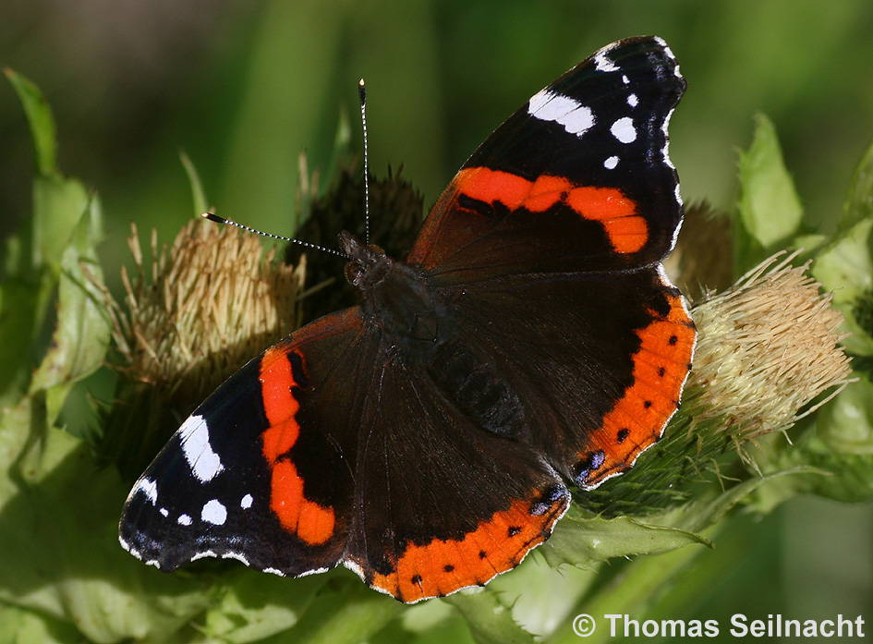
Admiral (Beispielkarte)
Text
Text
Text
Text
Text

Admiral
© Thomas Seilnacht
Text
Text
Text
Text
Text
Text

Admiral
Text
Text
Text
Text
Text
Text

Admiral
Text
Text
Text
Text
Text
Text

Admiral
Text
Text
Text
Text
Text
Text

Admiral

